
NGO SUSTAINABILITY
GLOBAL WARNING 1.2°C
LATEST NEWS IN SUSTAINABILITY
NO. 157 | November 2024
PROMOTING SUSTAINABLE LIVING AND RENEWABLE ENERGY FOR THE FUTURE OF OUR PLANET
ngosustainability@gmail.com | unngosustainability.org

Consultative Status, the United Nations Economic and Social Council (ECOSOC)
Observer Status, United Nations Environment Programme (UNEP)

Don’t hesitate to provide feedback here. Your comments are always welcome.
Please feel free to reproduce and share.
- NGO Sustainability Team
“A nation that destroys its soils destroys itself. Forests are the lungs of our land, purifying the air and giving fresh strength to our people.”
–Franklin Delano Roosevelt
Jennifer Granholm

Jennifer Granholm is an American politician and attorney who served as the 49th governor of Michigan from 2003 to 2011. A member of the Democratic Party, she was the first woman to hold the office of governor in Michigan. Born on February 5, 1959, in Vancouver, Canada, she moved to the U.S. with her family at age four. Granholm earned a bachelor’s degree in political science from the University of California, Berkeley, and a law degree from Harvard Law School. She began her career in law before transitioning into politics.

Granholm's gubernatorial tenure was marked by efforts to revitalize Michigan’s economy, particularly through initiatives to diversify the state's industrial base and support clean energy development. She played a pivotal role in securing federal aid for the auto industry during the 2008 financial crisis. After leaving office, Granholm became a prominent voice on national energy policy and served as a senior adviser to various organizations.

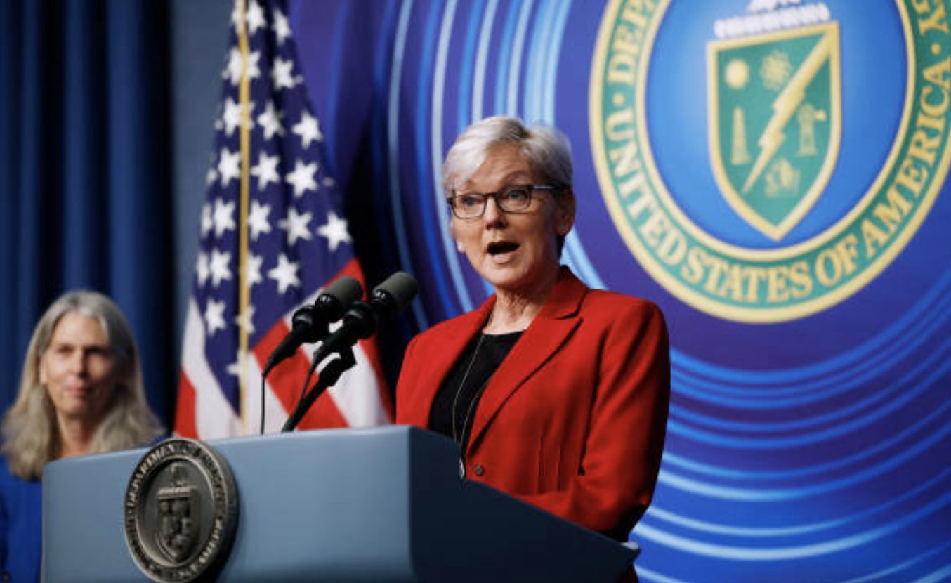
US Secretary of Energy, Jennifer Granholm
Source: Getty Images

In 2021, President Joe Biden appointed her as U.S. Secretary of Energy, where she focuses on advancing clean energy innovation, ensuring energy security, and addressing climate change. Granholm is also a frequent commentator on issues of economic policy and environmental justice.

Sources:
U.S. Department of Energy. (n.d.). Jennifer M. Granholm, Secretary of Energy. https://www.energy.gov
Michigan State Government. (n.d.). Governor Jennifer Granholm. https://michigan.gov

The Lake
By Sophie Cabot Black

Day and night, the lake dreams of sky.

A privacy as old as the mountains

And her up there, stuck among peaks. The whole eye

Fastened on hawk, gatherings of cloud or stars,

So little trespass. An airplane once

Crossed her brow; she searched but could not find

A face. Having lived with such strict beauty

She comes to know how the sun is nothing

But itself and the path it throws; the moon

A riddled stone. If only a hand

Would tremble along her cheek, would disturb. Even the elk

Pass by, drawn to the spill of creeks below—

How she cannot help abundance, even as it leaves

Her, as it sings all the way down the mountain.

“Climate Change: UN Report Says Planet to Warm by 3.1°C Without Greater Action”
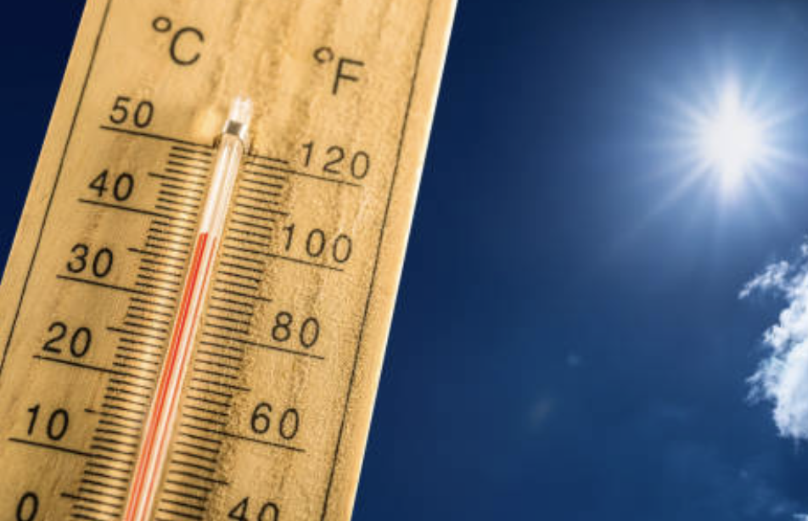
By: Gloria Dickie, Reuters
Photo: Getty Images
On October 24, the United Nations released its annual Emissions Gap report, which found a 1.3% rise in greenhouse gas emissions worldwide from 2022 to 2023. As a result, the UN warns countries that, without more resolute actions to reduce emissions, the world could warm by up to 3.1 degrees celsius above pre-industrial levels by 2100. Furthermore, the report states that, in order to meet the goal laid out in the 2015 Paris Agreement of stopping warming greater than 1.5 degrees celsius, emissions globally must be cut by 42% by 2030, and by 57% in 2035, a highly unlikely goal. UN Secretary-General Antonio Guterres warned of the consequences of the report’s findings, stating: “We're teetering on a planetary tight rope. Either leaders bridge the emissions gap, or we plunge headlong into climate disaster.”

Full Article

“Environmental Delegates Gather in Colombia for a Conference on Dwindling Global Biodiversity”
By: Steven Grattan, Associated Press
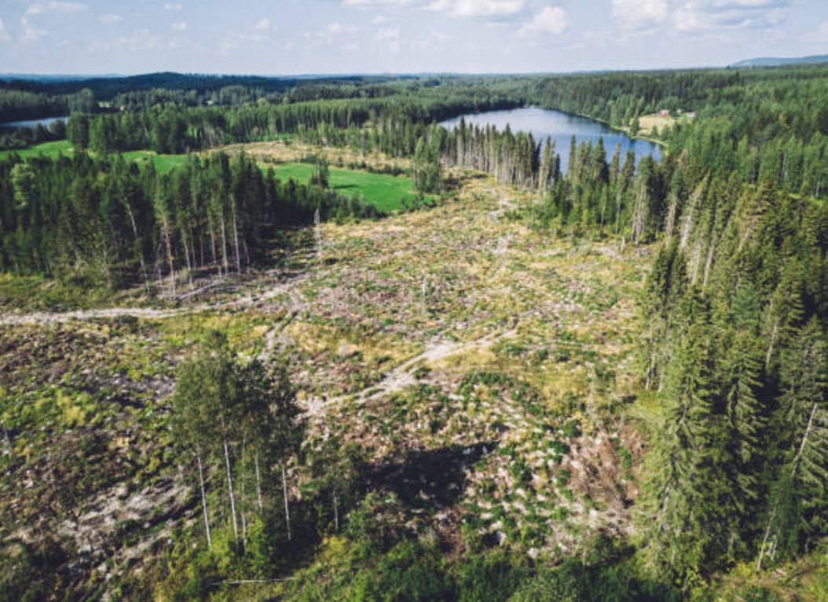
Photo: Getty Images
On October 21, environmental leaders worldwide met in Cali, Colombia, to begin the United Nations Biodiversity Conference (COP16). The conference comes two years after the leaders last met in Montreal to sign a “historic global treaty” on preserving biodiversity. COP16 also comes at a time when, according to the UN Environment Programme, roughly one million species of plants and animals are at risk of extinction, leading to the Earth going through “its largest loss of life since the dinosaurs.” Colombia’s status as the host country of this conference also highlights the importance of Indigenous peoples in biodiversity talks. Susana Muhamad, the environment minister of Colombia, notes the “political power” this demographic has, and emphasizes their role in helping craft solutions.

Full Article


“US Power Grid Added Battery Equivalent of 20 Nuclear Reactors in Past Four Years” By: Olive Milman, The Guardian
Photo: Getty Images
A new report by the Energy Information Administration (EIA) has found that the utility-scale batteries the U.S. has been installing over the past four years have added over 20 gigawatts of capacity to the power grid. This represents a sharp increase from the minimal amount of batteries added “just a few years ago,” and the EIA further predicts that – if the planned expansions comes to fruition – this figure could double next year. According to the report, this installation is the equivalent of 20 nuclear reactors’ output over the same time period. In California in particular, power outages that have become all too common during the summer time have been greatly reduced thanks to this expansion.

Full Article

“NYC Subway Riders See ‘Exceptionally High’ Air Pollution”

By: Maria Clara Cobo, Bloomberg
Photo: Getty Images

A study of New York City's subway system found dangerously high levels of fine-particle air pollution (PM2.5) that exceed safety guidelines, posing serious health risks for commuters. PM2.5 levels were 10 times higher on subway platforms and 7 times higher in train cars than the World Health Organization's recommended limits. The pollution, mainly from metal particles due to train friction, disproportionately impacts low-income, Black, and Hispanic commuters who rely on public transit. The research also found pollution spikes when trains entered stations, suggesting tunnels contribute to the problem. While the Metropolitan Transportation Authority (MTA) defends the subway as a green transportation option, the study calls for better air quality measures and a focus on environmental justice to protect vulnerable communities and ensure a safe transit system.

Full Article

“Time to Retire ‘Hard to Abate’ as Climate Solutions Become More Affordable
By: Akshat Rathi, Bloomberg
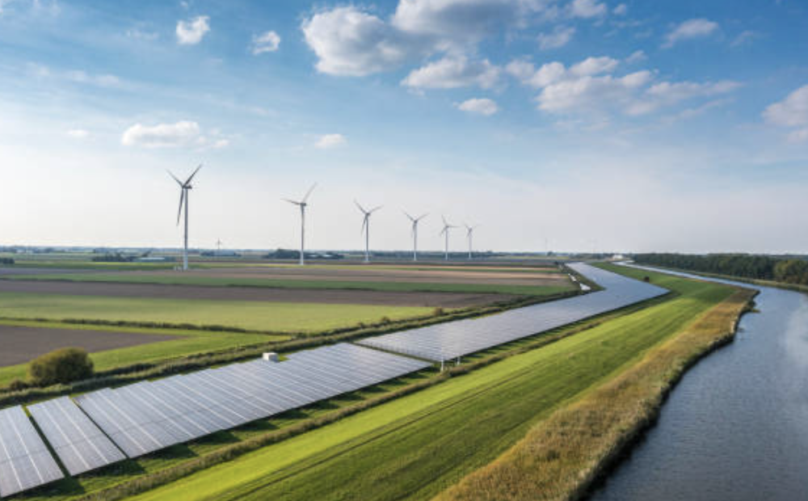
Photo: Getty Images

The term "hard to abate" is often used to describe industries like steel, cement, and aviation that face challenges in decarbonizing due to technology gaps, high costs, or weak regulations. However, experts argue this term can be misleading and allow industries to avoid action. Emerging technologies, such as carbon capture, renewable electricity, and green hydrogen, offer solutions to reduce emissions in these sectors. While costs remain high, they are decreasing with increased investment, research, and supportive policies. Michael Liebreich suggests the term should be "affordable to abate," noting that low-carbon technologies are becoming more cost-competitive. The shift in perspective, evident in growing net-zero commitments, shows that decarbonization is achievable with the right support, challenging the notion that some sectors are beyond meaningful climate action.

Full Article

“Hottest Sea in Four Centuries Add Threat to Great Barrier Reef”
By: Keira Wright, Bloomberg
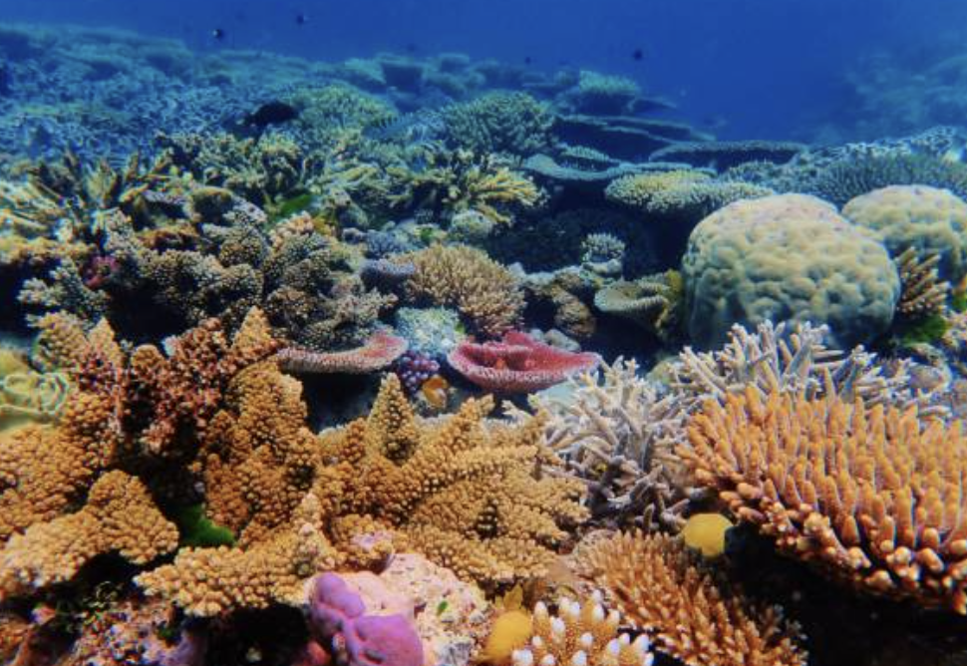
Photo: Getty Images
The Great Barrier Reef off the coast of Queensland, Australia, is at risk of near-annual coral bleaching due to rising ocean temperatures, which have reached their highest levels in at least 400 years. The Coral Sea has seen extreme heat peaks in 2021, 2017, and 2020, with scientists warning that the reef faces an existential threat from more frequent bleaching events if temperatures continue to rise. Researchers emphasize that without rapid global action on climate change, the reef could face collapse. Coral bleaching occurs when warmer waters expel the algae that corals depend on for food. The reef, which supports a $6.4 billion economy, has already experienced five mass bleaching events in the past decade. Urgent action to meet Paris Agreement targets and transition to renewable energy is critical to protecting the reef’s future.

Full Article

“Indonesia’s EV Ambitions Boosted by New BTR Battery Anode Plant”
By: Eko Listiyorini & Eddie Spence, Bloomberg
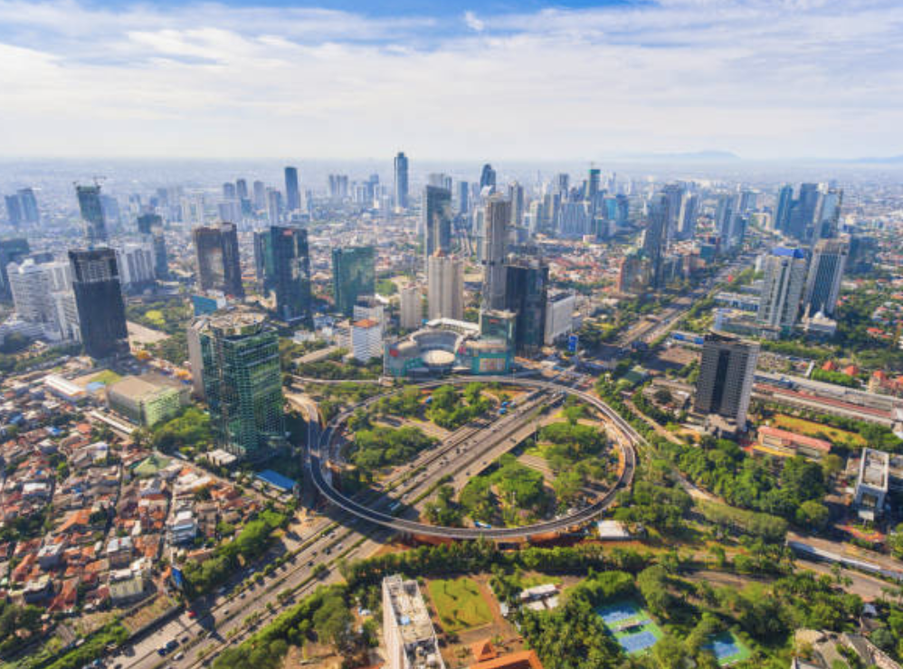
Photo: Getty Images
BTR New Material Group from China has opened a $478 million anode material manufacturing facility in Indonesia, marking a key step in the nation's effort to become a hub for electric vehicle (EV) production. Located in Kendal Industrial Park, Central Java, the plant began production in 2023, with an initial capacity of 80,000 tons of anode material annually, enough for 1.5 million EVs. Indonesian President Joko Widodo highlighted the facility's role in building a comprehensive EV supply chain, leveraging Indonesia’s abundant nickel resources. The plant will also use artificial graphite from PT Pertamina and imported natural graphite from Africa. Later this year, BTR plans to expand the plant’s capacity to 180,000 tons, positioning Indonesia as the world’s second-largest anode producer. The venture is partly owned by BTR and Singapore’s Stellar Investment Pte. Ltd.

Full Article

“ChargePoint Deploys New Plugs to Fit Teslas and Non-Teslas Alike”
By: Tope Alake, Bloomberg
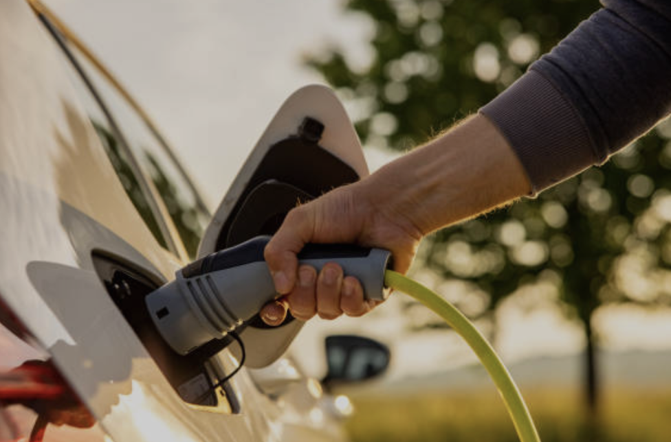
Photo: Getty Images
ChargePoint Holdings Inc., operator of the largest EV charging network in the U.S., has unveiled the Omni Port, a new plug designed to be compatible with a wide range of electric vehicles (EVs). The Omni Port combines the most commonly used EV connector types, making it compatible with both AC (Alternating Current) and DC (Direct Current) chargers. This innovation addresses a long-standing issue for EV drivers: the lack of a universal charging standard. Currently, the U.S. EV charging landscape is split between the Combined Charging Standard (CCS) and Tesla’s North American Charging Standard (NACS), the latter gaining traction as automakers like Ford, GM, and Rivian transition to NACS. ChargePoint’s Omni Port aims to streamline the charging experience, ensuring compatibility for both Tesla and non-Tesla vehicles, and positioning ChargePoint as a leader in EV infrastructure development.

Full Article

National Geographic
Nikolai Stephens-Zumbaum (NGO Intern)

National Geographic is a global leader in environmental journalism, renowned for its exceptional photography, groundbreaking expeditions, informative television programming, and unwavering commitment to exploring our planet.
Until 1920, National Geographic was managed by a single Editor in Chief. Since 1967, however, the magazine has had an Editor in Chief dedicated solely to overseeing its editorial content. Nathan Lump has held this position since May 2022.
Founded in 1888 by 33 scholars, National Geographic’s mission has always been to “increase and diffuse knowledge.” Its first major expedition took place in 1890, when Israel Russell led an exploration of the Mt. St. Elias region in North America. Originally an academic journal, National Geographic began incorporating photography in the early 20th century, with its first color images appearing in the 1910s. Over time, visual storytelling became central to the publication’s identity.
By the mid-1980s, the magazine boasted a circulation of 12 million subscribers in the U.S., with millions more internationally. National Geographic’s evolution continued into the 21st century, culminating in 2015 when National Geographic Partners took over. With 21st Century Fox acquiring a 73% controlling interest and the subsequent acquisition by Disney, National Geographic now operates under the Disney umbrella.
In addition to its media offerings, National Geographic provides a range of educational materials, from virtual learning experiences to free resources designed to empower educators worldwide. The organization is a champion of cutting-edge scientific research, focusing on six primary areas: ocean exploration, land conservation, wildlife protection, human histories and cultures, planetary health, and space exploration.
To sustain its efforts, National Geographic funds a variety of research grants, educational programs, media productions, and other operational needs, ensuring its continued leadership at the forefront of exploration and science.

Sources
National Geographic Society. (n.d.). Our story. National Geographic. Retrieved November 18, 2024, from https://www.nationalgeographic.org/society/our-story/
Wikipedia contributors. (2024, November 14). National Geographic. Wikipedia, The Free Encyclopedia. Retrieved November 18, 2024, from https://en.wikipedia.org/wiki/National_Geographic
National Geographic Society. (2022). 2022 annual report. National Geographic. Retrieved November 18, 2024, from https://www.nationalgeographic.org/society/2022-annual-report/

Wyland Foundation & UN Ocean Conference
Alex Kawa (NGO Intern)

Background
The Wyland Foundation was founded in 1993, with the goal of ocean, water, and natural resource conservation. In describing the organization’s founder, artist and conservationist Robert Wyland, the foundation states that he:
“[...] changed the way people think about our ocean when he started painting life-size whales on the sides of buildings in the 1980s. Wyland always thought big […]. In the over thirty years, he has continued to evolve and shape public attitudes about the need to protect marine ecosystems by calling attention to the plight of endangered species, but also focusing on threats to marine ecosystems resulting from land-based activities, including marine debris and polluted runoff.”

Efforts
The Wyland Foundation focuses its efforts in multiple departments, including traveling to schools across the U.S. to teach water science to students, providing resources for teachers to use in the classroom, and hosting an annual Wyland National Mayor’s Challenge for Water Conservation, in which mayors of American cities work on efforts towards water conservation.

The Wyland Foundation is further notable for its work with U.S. government agencies such as the Environmental Protection Agency “to drive initiatives that encourage people worldwide to become more positive, solution-oriented stewards of our oceans and protect our natural resources.” It does similar work with the United Nations, which is important as the UN gears up for its annual Ocean Conference in 2025.

UN Ocean Conference
The 3rd UN Ocean Conference will take place in June 2025 in France, which is hosting the summit with Costa Rica as its co-sposner of the conference. The goal of the conference is to work towards implementing one of the UN’s Sustainable Development Goals, this one being the 14th goal, which calls to “Conserve and sustainably use the oceans, seas and marine resources for sustainable development.” The UN states that the summit will prioritize the building of partnerships between public- and private-sector institutions to work towards ocean sustainability. These institutions include state governments, NGOs, academia, and foundations.

This is where the Wyland Foundation has the potential to come into play. As a nonprofit organization focused heavily on combating pollution and conserving oceans, it could play a significant role in shaping the agenda of the conference. With a record of educating on the importance of conservation, as well as working with elected officials to ensure that conservation remains a priority for them. The organization will be an important influence on the forthcoming Ocean Conference in June 2025.

Sources
Wyland Foundation. (n.d.). Our founder. Wyland Foundation. Retrieved November 13, 2024, from https://wylandfoundation.org/our-founder/
Wyland Foundation. (n.d.). Programs. Wyland Foundation. Retrieved November 13, 2024, from https://wylandfoundation.org/programs/
United Nations. (2023, September 4). Ocean Conference 2025. United Nations. Retrieved November 13, 2024, from https://sdgs.un.org/conferences/ocean2025

Producer: Roma Stibravy, NGO Sustainability President
Editors: Adrianna Mannino, Columbia University School of Professional Studies
Contributors: NGO Sustainability Interns and Associates

Corporate Sponsors



MAKE A DIFFERENCE!
BECOME A MEMBER OF NGO SUSTAINABILITY!
SEE CORPORATE SPONSORSHIP OPPORTUNITIES
unngosustainability.org

Sophie Cabot Black "The Lake", 2003. https://www.poetryfoundation.org/poetrymagazine/poems/41721/the-lake-56d21ffc656c8

