
`
NGO SUSTAINABILITY
GLOBAL WARNING +1.2°C
In celebration of the 75th annual Earth Day, April 22nd, 2024.
LATEST NEWS IN SUSTAINABILITY
NO. 150 | April 2024
PROMOTING SUSTAINABLE LIVING AND RENEWABLE ENERGY FOR THE FUTURE OF OUR PLANET
ngosustainability@gmail.com | unngosustainability.org

Consultative Status, the United Nations Economic and Social Council (ECOSOC)
Observer Status, United Nations Environment Programme (UNEP)

Your comments are always welcome.
Please feel free to reproduce and share with your colleagues.
- NGO Sustainability team
“We live as part of an amazing organism that has the capacity to regenerate, given a chance. We also live in the waste stream. Garbage is a combat zone where our desire for comfort and function meets the limits of our nest.”
– Christy Rupp, American Eco Artist
Leena Ylä-Monon.
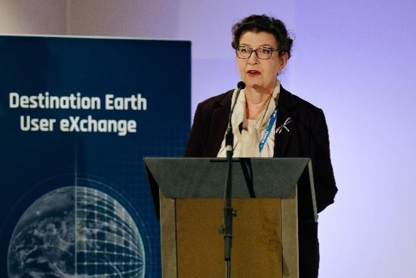
Leena Ylä-Mononen is the Executive Director of the European Environmental Agency (EEA). Her background includes roles in managing industrial chemicals, biocides, and pesticides at the Finnish Environment Institute, serving as a policy officer in the European Commission's Directorate General for the Environment from 2004 to 2007, and holding senior positions at the European Chemicals Agency until 2019. Notably, in 2019, Ylä-Mononen was appointed the General Director at the Finnish Ministry of Environment, overseeing the Ministry's Climate and Environmental Protection Department. Ylä-Mononen has been vocal about Europe's lack of preparation for the impending climate risks, urging governments to act to meet climate targets. Under her leadership, the EEA launched the European Climate Risk Assessment (EUCRA),

Leena Ylä-Monone speaking at the 2nd DestinE User eXchange meeting.

which identifies and assesses 36 major critical climate risks across various sectors including food, health, economy and finance.

Earth Day
By Jane Yolen

I am the Earth

And the Earth is me.

Each blade of grass,

Each honey tree,

Each bit of mud,

And stick and stone

Is blood and muscle,

Skin and bone.

And just as I

Need every bit

Of me to make

My body fit,

So Earth needs

Grass and stone and tree

And things that grow here

Naturally.

That’s why we

Celebrate this day.

That’s why across

The world we say:

As long as life,

As dear, as free,

I am the Earth

And the Earth is me.
“What is Earth Day, when is it and what has it achieved?”
By: Mark Poynting & Maddie Molloy, BBC
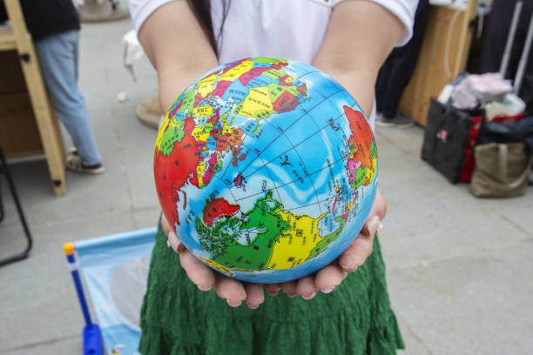
Photo: Getty Images
Earth Day, initiated in 1970 by U.S. Senator Gaylord Nelson and Harvard graduate Denis Hayes, is celebrated globally on April 22nd to raise environmental awareness. Originally a national event with 20 million participants, it now engages over a billion people in nearly 200 countries. The 2024 theme, "Planet vs. Plastics," focuses on combating plastic pollution. This coincides with an anticipated historic UN treaty aimed at ending plastic pollution by 2040. Earth Day has led to significant environmental achievements, including the establishment of the U.S. Environmental Protection Agency and key legislation like the Clean Air Act.

Full Article

“There’s an Explosion of Plastic Waste. Big Companies Say ‘We’ve Got This”
By: Hiroko Tabuchi, New York Times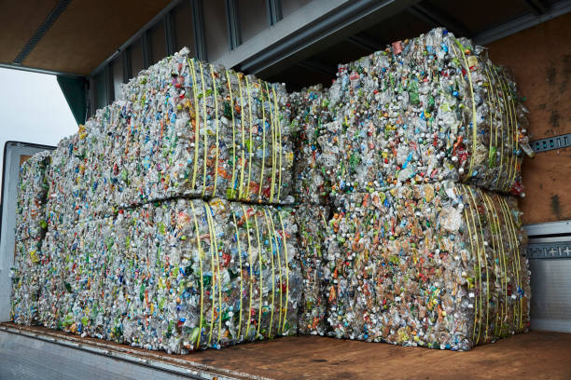
Photo: Getty Images
L’Oreal is pledging that its packaging will be entirely “reusable, recyclable, refillable or compostable” by 2025. Nestle also aims to not produce products with plastic that are not recyclable. Their goal is to promote a new suite of recycling plants, and despite initial hurdles with advanced recycling, the plastics industry says the global waste dilemma is solvable by new technology. Instead of breaking down and melting plastic, facilities like PureCycle Technologies can break down materials in single-use items like coffee pods or yogurt tubs and transform them into new plastics. The chemical-recycling plants in the US operating at full capacity could process around 456,000 tons of plastic, about 10% of the country’s production. The company has experienced setbacks over the types of material it can use to create pellets and the scale of activity, however setbacks for any new technology are not unusual and the efforts can transition the industry to a circular economy.

Full Article

“Global plastics treaty talks are happening. What do stakeholders want?”
By: Valerie Volcovici, Reuters
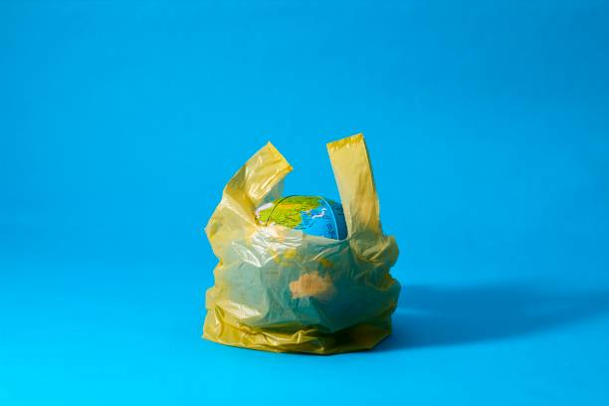
Photo: Getty Images
Global negotiations for an international treaty aimed at reducing plastic pollution are underway, with stakeholders gathering in Ottawa, Canada at the end of April. The treaty intends to regulate plastic across its entire lifecycle, from production to disposal. The negotiations, however, face significant challenges due to differing stances among countries on how to address the issue. Some nations, including major plastic and petrochemical producers resist imposing production limits. In contrast, the "High-Ambition Coalition," which includes EU countries and others, advocates for stringent measures such as phasing out problematic single-use plastics and setting production caps. The hope is that a consensus will be found before the final negotiations scheduled for December in Busan, South Korea.

Full Article
“Aldi Sets a New Standard in the Recycling of Challenging Flexible Plastics”
By: ESG News
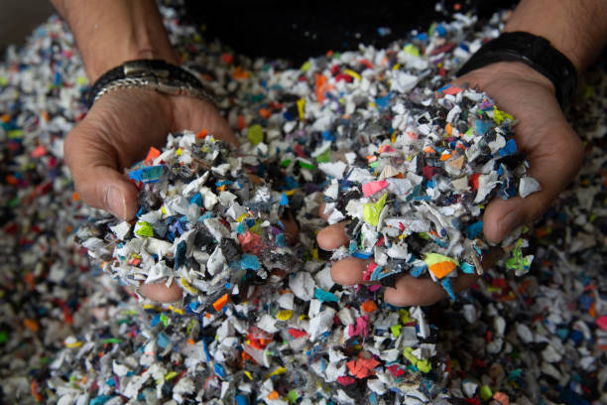
Photo: Getty Images
Together with the Flexible Plastic Fund (FPF), Aldi, a UK supermarket chain, is advancing their recycling practices. Through employing the eco2Veritas system developed by Greenback, Aldi is tracking the entire journey of flexible plastic from collection points to recycling into end products. The FPF verifies and provides support for the company’s recycling initiatives, offering funding for certified recycling efforts. Recently, Aldi received its first certification, confirming the recycling of 62 tonnes of Polyethylene and 25 tonnes of Polypropylene. With an annual collection of around 300 tonnes, Aldi collaborates with Jayplas to sort and recycle the plastic into various end products to further confirm their dedication to plastic sustainability.

Full Article

“The Last Coal-Fired Power Plants In New England Are to Close”
By: Minho Kim, The New York Times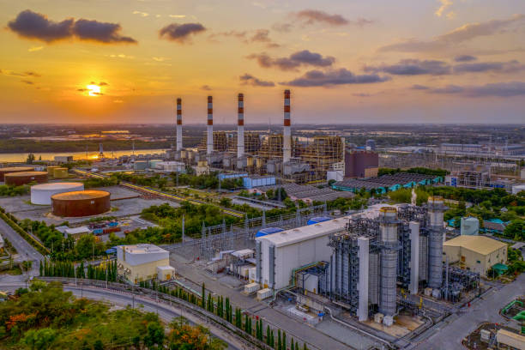
Photo: Getty Images
The last two coal-fired power plants shutting down in New England will make it the second region to stop using the fossil fuel and help ameliorate the 59% of national carbon emissions produced from coal in 2021. The Merrimack and Schiller stations will be converted to battery units and solar farms for energy storage from offshore wind turbines following a five-year legal battle from environmentalists. With the increase in national demand for energy, coal-fired plants could be delayed in closing but the industry is shrinking, as it supplied only 17% of US electricity last year. The Conservation Law Foundation lobbied to separate the utilities and the power plant owners so that the latter could transition to renewable energy.

Full Article

“Plastic particles in bottled water”
By: Vicki Contie, National Institute of
Health
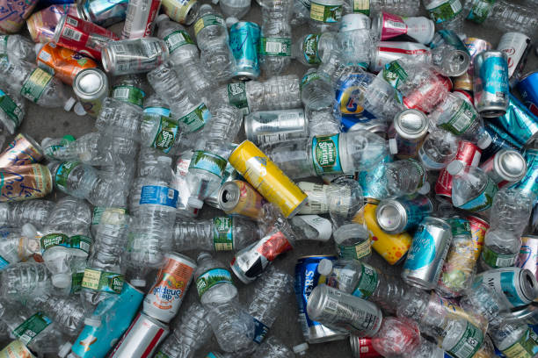
Photo: Getty Images

We are increasingly aware that plastics break down into microplastics and nanoplastics
that are entering human tissues, with health impacts that are currently unknown. Researchers at Columbia University have developed stimulated Raman scattering (SRS) microscopy, which is a revolutionary imaging technique, to detect these plastics at the single-particle level. The study revealed that there is an alarming level of nanoplastics in bottled water, with an average of 240,000 particles per liter. This technique has a non-labeling approach that allows rapid identification of common plastic types, which will give more insight into human nanoplastic exposure, helping to lead to the ability to mitigate plastic pollution impacts on both human health and the
environment.

Full Article

“Plastic pollution amplified by a warming climate”
By: Xin-Feng Wei, Wei Yang, & Mikael S. Hedenqvist, Nature Communications
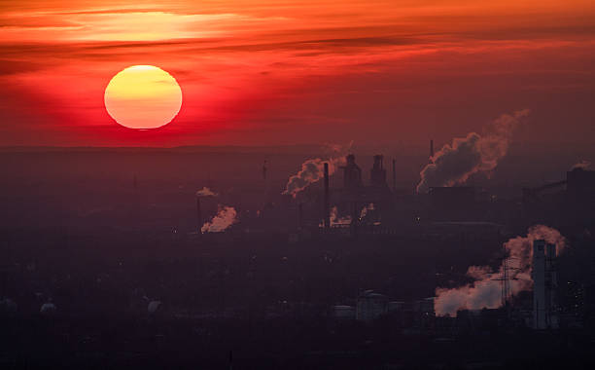
Photo: Getty Images

Climate change and plastic pollution are both impacted by rising temperatures and moisture,
which can alter plastic properties and increase waste generation, microplastic creation, and the
release of harmful substances. Earth’s temperature has surpassed 1°C above pre-industrial levels, with extreme heat waves exceeding 10°C above normal levels, which is causing severe harmful impacts on ecosystems and societies. The increasing demand for plastic materials due to climate related disasters and infrastructures further exacerbates plastic pollution. Also, as plastics degrade quicker in warmer climates, this intensifies leaching of harmful chemicals and increases microplastics risks, which triggers a cycle between climate change and plastic pollution. There are urgent and collaborative efforts needed to address these issues through technological innovation, sustainable practices and global policy.

Full Article

“Microplastics and Nanoplastics in Atheromas and Cardiovascular
events”
By: Marfella et al., The New England Journal of Medicine
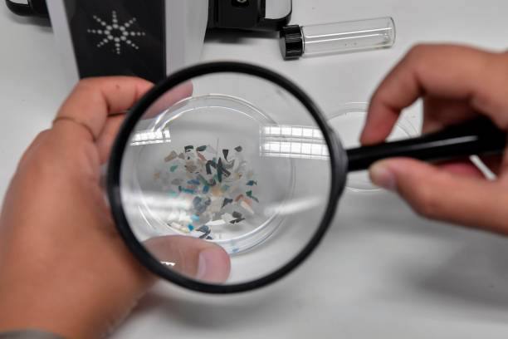
Photo: Getty Images
Microplastics and nanoplastics are potential cardiovascular risk factors. A prospective observational study looked at carotid artery plaques from 304 patients undergoing carotid endarterectomy. These plastics, mostly polyethylene and polyvinyl chloride, were found in 58.4% and 12.1% of the samples, respectively, through advanced analytical techniques. The plastics were seen embedded within plaque macrophages through electron microscopy. The patients with these plastics had a significantly higher risk of stroke and even death within 34 months compared to those without plastics, highlighting yet another human health issue related to plastic pollution.

Full Article

Earth Day 2024: Planet vs. Plastics
Catie Eiref (NGO Intern)

Earth Day was first celebrated on April 22, 1970. It was established as a response to the increasing environmental concerns of the 1960s – specifically the increase in pollution and its impacts on natural resources. The idea for earth day was initially led by Senator Gaylord Nelson who envisioned a national day of teach-ins that would engage broader Americans to participate in environmental protection. The vision for Earth Day quickly spread, becoming a national, and later global event aimed at raising awareness and engagement around environmental issues.

Even in the early years, Earth Day saw incredible participation, with over 20 million Americans from various cities and academic institutions participating in 1970. This widespread engagement played a key role in guiding early US environmental legislation, aiding in the establishment of the Environmental Protection Agency as well as critical laws like the Clean Air Act, Water Quality Improvement Act, and the Surface Mining Control and Reclamation Act. Today, Earth Day is celebrated across the globe, with 17,000 partners and organizations in 174 countries and over 1 billion participants, making it the largest secular civic event in the world. It remains a day for advocating for environmental actions as well as fostering collaboration around protecting our planet for the future generations.

Since the 1970’s, Earth Day has evolved to address modern environmental challenges. Earth Day 2024 is set to focus on the global fight against plastic pollution under the theme “Planet vs. Plastics”. This initiative by the organizers of Earth Day is aimed toward emphasizing the need to phase out single use plastics and address the environmental impact of the fast fashion industry, pushing for a 60% reduction in plastic production by 2040. This year aims to highlight both the issue of plastic pollution in our ecosystems as well as the health risks of microplastics in our food and water supply and the toxic chemicals associated with plastic manufacturing. This year, Earth Day will also promote initiatives and technologies that can help create a plastic-free future and push for the implementation of a Global Plastics Treaty.

For more information on how you can participate and support Earth Day 2024 initiatives, visit Earth Day 2024.
References:
Earth day 2024 - origins, theme, celebration. (2024). Retrieved from
https://www.history.com/topics/holidays/earth-day
Earth day 2024: Activities & Resources for April 22. (2024a). Retrieved from
https://www.earthday.org/earth-day-2024/
The history of earth day. (2024b). Retrieved from https://www.earthday.org/history/
Planet vs. plastics. (2023). Retrieved from https://www.earthday.org/planet-vs-plastics/

Christy Rupp’s Ecological Art
Paula Grandas (NGO Intern)
Christy Rupp is an American ecological art activist and citizen scientist who aims to raise awareness about “the species in the crosshairs of survival” by using unique materials and practices. She has been working for several decades studying animal behavior and the environment to transform recycled trash items like single-use plastic, credit cards, and chicken bones into art pieces. With various exhibitions shown worldwide since she emerged in the art world in the 1970s, her work has been understood as a form of activism.

From a young age Rupp was aware that “the language we use to describe the environment establishes our place in the natural world.” She studied at the San Francisco Art Institute where she immersed herself in the art trends of the 1960s and 1970s such as conceptualism and environmental activism. After completing her studies, she settled in New York City and became a pioneering figure in the emerging field of ecological art.

Her artistic themes are the exploration of the interconnectedness between human society and wildlife and explain why we are in a time when our planet has been irreversibly transformed by the influence of Humans. Specifically, Rupp explores the intersections of geopolitical dynamics, cultural influences, and economic factors in shaping the fragilities of ecosystems. Through her artistry, Christy Rupp examines the ecological impacts of geopolitical borders and resource management, while, at the same time, the implications of climate change on human displacement.

She also criticizes consumer culture and its role in perpetuating ecological degradation. By using discarded materials and everyday objects such as food waste and plastics that come from non-reusable bottles, toothbrushes, and bags, she transforms the litter of modern society into thought-provoking artworks on the excess of contemporary life.

Additionally, she exposes how economic policies create macro-ecological disasters. She has used credit cards to create many of her sculptures, conveying the message that profit movies are at the expense of harming species and habitats. She has also used steel, bones, and wax made out of petrochemicals to symbolize oil spills and fossil fuel dependence that has contributed to the endangerment and even extinction of species. Christy Rupp’s art has been displayed in galleries and museums all over the world such as the Schunck Museum in Heerlen, Netherlands; Museum of Arts and Design, New York; Zimmerli Art Museum; and ABC No Rio in Exile.

References:

Cross Contemporary Art Projects. (n/a). Christy Rupp. Retrieved from Cross Contemporary Art Projects:https://www.crosscontemporaryprojects.com/artists/51-christy-rupp/
Dragon, J. (2024). Christy Rupp | Streaming. Retrieved from Dart International
Magazine:https://www.dartmagazine.com/?p=3156
Fairfield News. (2024). Streaming: Sculpture by Christy Rupp Exhibition Opens Jan. 18. Retrieved from Fairfield News: https://www.fairfield.edu/news/archive/2024/january/fuam-streaming-sculpture by-christy-rupp-opening.html
Lord, M. (2024). Environmental Artist Christy Rupp Anchored at Fairfield. Retrieved from Artscope

Producer: Roma Stibravy, President
Editors: Catie Eiref - Columbia University Mailman School of Public Health
Adrianna Mannino - Stony Brook University School of Marine and Atmospheric Sciences
Contributors: NGO Sustainability Interns
BECOME A MEMBER OF NGO SUSTAINABILITY!
SEE CORPORATE SPONSORSHIP OPPORTUNITIES
unngosustainability.org

Jane Yolen. "Earth Day", 1995. https://www.poetryfoundation.org/poems/54673/earth-day.

