
NGO SUSTAINABILITY
GLOBAL WARNING 1.2°C
LATEST NEWS IN SUSTAINABILITY
NO. 156 | October 2024
PROMOTING SUSTAINABLE LIVING AND RENEWABLE ENERGY FOR THE FUTURE OF OUR PLANET
ngosustainability@gmail.com | unngosustainability.org

Consultative Status, the United Nations Economic and Social Council (ECOSOC)
Observer Status, United Nations Environment Programme (UNEP)

Don’t hesitate to provide feedback here. Your comments are always welcome.
Please feel free to reproduce and share.
- NGO Sustainability Team
“The world changes according to the way people see it, and if you alter, even by a millimeter, the way a person looks or people look at reality, then you can change it.”
–James Baldwin
Rachel Kyte

Rachel Kyte is the UK's Special Representative for Climate, a role she took in September 2024 to advance the UK's international climate agenda in the lead up to and during the COP26 climate conference in Glasgow, and she previously served as the dean of The Fletcher School at Tufts University, where she significantly advanced the school's mission in global affairs and climate policy. She has a significant career in sustainable development and climate policy, previously serving as the CEO of Sustainable Energy for All and as Vice President for World Bank Group’s Climate Change Group.

Kyte has been an advocate for integrating climate action into broader development strategies and has emphasized the importance of finance in addressing climate change. Her work focuses on fostering international cooperation and mobilizing resources to support climate resilience and sustainable development.

Kyte is also recognized for her influential voice in international climate discussions, advocating for vulnerable communities and promoting equitable solutions.

UK Special Representative on Climate, Rachel Kyte
Source: GOV.UK

She has shaped global climate finance, emphasizing investment in renewable energy and sustainable infrastructure. As a sought-after speaker, Kyte shares insights on the intersection of climate action and economic growth, fostering collaboration among governments, businesses, and civil society in the fight against climate change.

Sources:
UK Government. (n.d.). Rachel Kyte. https://www.gov.uk/government/people/rachel-kyte
Kyte, R. (n.d.). Team. World Bank Blogs. https://blogs.worldbank.org/en/team/r/rachel-kyte
University of Oxford, Blavatnik School of Government. (n.d.). Rachel Kyte. https://www.bsg.ox.ac.uk/people/rachel-kyte-0
Wikipedia contributors. (n.d.). Rachel Kyte. In Wikipedia, The Free Encyclopedia. Retrieved October 11, 2024, from https://en.wikipedia.org/wiki/Rachel_Kyte
Fletcher School. (2023, October 10). Dean Rachel Kyte steps down. Tufts University. https://fletcher.tufts.edu/news-events/news/dean-rachel-kyte-steps-down

There Once Used To Be Green
By Aayat Irfan

There once used to be green everywhere,

Now the green has changed its attire.

To a rebellious and furious orange,

Nothing but a ferocious wildfire.

There once used to be green everywhere,

Now the green has been a victim to killings.

It cried helplessly,

Nothing but lofty concrete buildings.

There once used to be green everywhere,

Now the green has been ripped apart into a maze.

Destructed mercilessly, it begged in pain,

Nothing but straight cement pathways.

There once used to be green everywhere,

Now the green is being pitilessly strangled to death.

It is urgently trying to seek a way out,

Because we have held its breath.

“State Calls for More Climate Change Adaptation Projects”
By: Kevin Glass, NBC Connecticut

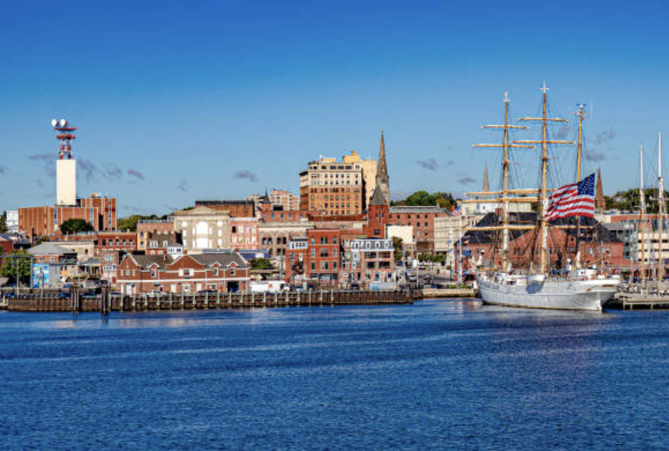
Photo: Getty Images
The state of Connecticut has already taken several measures to adapt to the impacts of climate change. For instance, in Meriden, the town green has been adapted to hold up to 53 acre-feet of water. The success of this project has encouraged the state Department of Energy and Environmental Protection to revamp its Climate Resiliency Fund to help municipalities execute similar projects relating to adaptation. “The cost of climate change is being felt all across the state,” Commissioner Katie Dykes states. “We know there are lots of measures municipalities can take to reduce known risks.”

Full Article

“Climate Change Made Hurricane Milton Stronger, With Heavier Rain, Scientists
Conclude”
By: Sean Sublette, InsideClimate News

Photo: Getty Images
A study of Hurricane Milton highlights that climate change intensified the storm by 40%, leading to rainfall levels that were 20 to 30% higher than those of previous hurricanes. An unusual phenomenon linked to the warmer waters of the Gulf of Mexico caused the storm to intensify rapidly, with wind speeds reaching up to 95 mph in just one day. Accompanied by severe wind shear that triggered a tornado outbreak, Hurricane Milton made landfall as a Category 3 storm. Scientists emphasize that rising temperatures are contributing to stronger storms, and Milton's sudden intensification exemplifies the shifting behavior of hurricanes as a direct consequence of climate change.

Full Article

“Silicon Valley Renegades Pollute the Sky to Save the Planet”
By: David Gelles, The New York Times


Photo: Getty Images

Make Sunsets is a startup in California’s Silicon Valley that employs a somewhat novel solution to the crisis of air pollution. Make Sunsets focuses on releasing sulfur into the air, with the goal of the pollutant reflecting the energy of the sun into space. The founders argue this process is essential to cooling the planet’s temperatures. This strategy does have some scientific basis, with research over the past half-century having “suggested that releasing aerosols into the stratosphere could act as a buffer and reduce the heat from the sun”. However, it is not a strategy that has intentionally been employed before. With millions of dollars in funding, Make Sunsets is attempting to employ geoengineering techniques.

Full Article
“New California Lawsuit Claims Exxon’s Baytown Plastic Recycling Plant was Key to Public Deception”
By: Rebekah F. Ward, Houston Chronicle
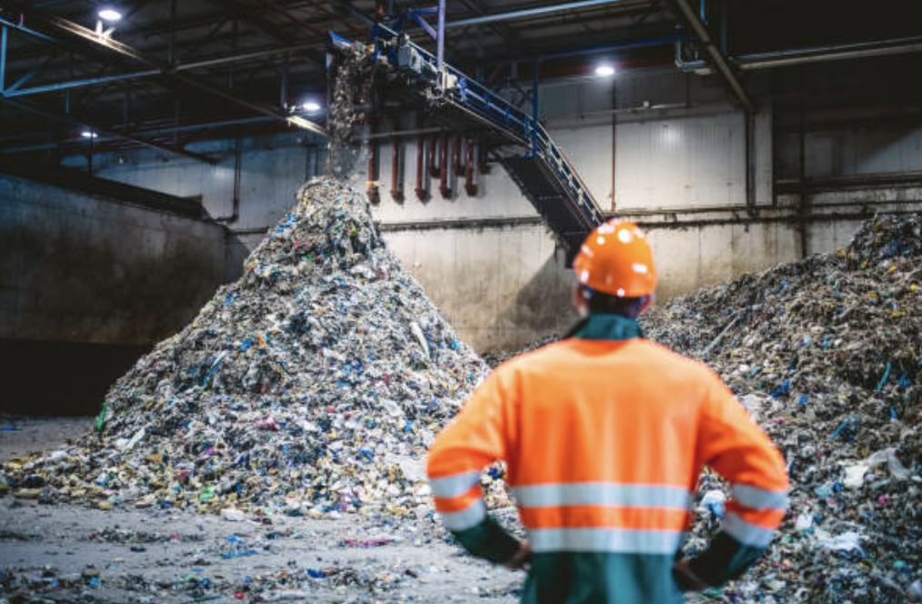
Photo: Getty Images

In Houston, ExxonMobil has launched a program to revolutionize plastic recycling. However, a complaint filed in California’s highest court explained that these were false promises about efficiency. The lawsuits state Exxon promotes advanced recycling as a “technological wonder”, but instead has misled the public about its capabilities and processing, due to the fact that only 8% of the plastics recycled actually become new plastics while the other portions get burned up as fuel. Thus, Exxon has contributed to more plastic pollution while greenwashing their solutions. However, Exxon has responded stating that the advanced recycling works and that they have processed 60 million pounds of plastic. Its promise has garnered scrutiny from environmentalists as being deceptive and a public nuisance.

Full Article

“Experts Advise Residents Affected By the La Porte Pipeline Fire To Watch For Health After Effects”
By: Faith Bugenhagen, HoustonPress

Photo: Getty Images

In La Porte, Texas the natural gas pipeline fire has many after effects, forcing nearby residents to take precautions. Even after the fire was out, experts indicate that there were still high levels of harmful compounds in the atmosphere. The TCEQ explained there were large amounts of volatile organic compounds over the 10 hours while the fire started. However, the fire burned for around 4 days until extinguishing itself Thursday. Fire emissions have also been tied to high ozone levels. Houston generally contains many pipelines vulnerable to spills, and Texas has the most pipeline infrastructure of any other state. The fire erupted after an SUV struck a fence and is under criminal investigation.

Full Article
“Wildfires are Burning Through Humanity’s Carbon Budget, Study Shows”
By: Jonathan Watts, The Guardian


Photo: Getty Images
The Meteorological Office (Met Office) of the United Kingdom recently released a study finding that the increase in wildfires has led to a “burning through” of the carbon budget that has been set in order to limit global warming. Wildfires have become much more frequent in recent years, all the way from Brazil to the Arctic, as rainy seasons have been cut short due to increasing droughts, which is in turn caused by rising global temperatures. The most concerning portion of the office’s research finds that “the latest temperature at which, globally, these impacts become pronounced is 1.34C – close to current levels of warming [above pre industrial levels].” Lead author Dr. Chantelle Burton further notes how the increasing rate of these fires has severely compromised forests’ ability to store and sequester carbon.

Full Article

“In NYC and elsewhere, climate protesters say pace of change isn’t fast enough”
By: Seth Borenstein, Associated Press
Photo: Getty Images
Protesters in New York and other major cities across the world are demanding more from their governments. These protests during a week in September have become an annual event ever since Greta Thunberg’s protest at the Swedish parliament six years ago, and are organized by the group Fridays for Future. Many of these protesters target specifically some of the highest-polluting companies, as well as the financial institutions that fund them, as the source of the problem, and are encouraging policymakers to do the same.

Full Article

“The Secret Weapon to Fight Flooding Is Hidden in Plain Sight”

By: Dodai Stewart, The New York Times
Photo: Getty Images
New York City has been implementing a new antidote to the growing problem of street flooding. As Sarah Lawrence College environmental science professor Bernice Rosenzweig states, “We’ve replaced almost all of our natural surfaces with buildings, with streets, with sidewalks with anything that’s paved”. Now, new surfaces are being installed as side drains across more than two-thirds of the city, and they are much more absorbent than even natural surfaces. As a result, they are able to reduce the effects of mass flooding, and their impacts – dating back to 2017, when they were introduced in a pilot program – have so far been positive.

Full Article
The United Nations Summit of the Future
Alex Kawa (NGO Intern)

Introduction
Between September 20 and 23, 2024, the United Nations (UN) held its Summit of the Future in New York. This summit, held by the UN General Assembly, discussed global climate action strategies. During the summit, the assembly adopted the Pact for the Future and the Global Digital Compact. These actions by the UN are integral in its mission to build a more sustainable future globally.

Pact for the Future
The Pact for the Future focuses on five main areas: “sustainable development; international peace and security; science and technology; youth and future generations and transforming global governance.” The pact is 42 pages long, and a call to action, as stated by Secretary-General Antonio Guterres, who remarks that this pact is more than “just [an] agreement.”

The key pillars of the pact include accelerating the 2015 Paris Agreement and Sustainable Development Goals (SDGs), including young people in decision-making processes, and strengthening civil society/private sector partnerships.

Global Digital Compact
The Global Digital Compact (GDC) is described by the UN as “the first truly worldwide agreement on the international regulation of artificial intelligence (AI) and is founded on the idea that technology should benefit everyone.” The General Assembly’s adoption of this compact is somewhat of a follow-up to the release earlier in September of a report known as “Governing AI for Humanity,” a UN High-level report.

The compact includes provisions such as human rights safeguards – including protections for free speech and privacy – in a digital form, and affordable/inclusive connectivity in order to not leave behind communities which have historically suffered from a lack of internet access. Furthermore, the GDC emphasizes sustainable development of new technologies, with the goal being for digital innovations to be used to further the SDGs.

Conclusion
The Pact for the Future and Global Digital Compact outline a plan for the international community to take tangible actions on climate change and sustainable development. However, whether or not governments take action to implement these goals remains to be seen. There was much dissatisfaction with several of the provisions of the two adopted plans, with the deputy foreign minister of Russia claiming that, “No one is happy with this pact.” However, there is optimism among the international community that the goals of these agreements may be realized, with Guterres exclaiming that the pact in particular “open pathways to new possibilities and opportunities.” Meanwhile, Chancellor Olaf Scholz of Germany notes how the community will be judged by both history and younger generations should they fail to implement the goals of the pact. Overall, time will tell if the goals of these two agreements will fully come to fruition.

Sources
United Nations. (n.d.). Summit of the future. Retrieved October 11, 2024, from https://www.un.org/en/summit-of-the-future
United Nations. (2024, September 23). UN summit to address global challenges and future of humanity. UN News. https://news.un.org/en/story/2024/09/1154671
AP News. (2024, September 22). UN pact aims to tackle challenges of the future, but faces resistance. https://apnews.com/article/un-pact-future-russia-challenges-climate-ai-accf4523e01c6604707189333de289ce
Walther, C. (2024, September 22). The new UN global digital compact: What it is and why we matter. Forbes. https://www.forbes.com/sites/corneliawalther/2024/09/22/the-new-un-global-digital-compact-what-it-is-and-why-we-matter/

Community Solar Energy
Emma Terjesen (NGO Intern)

What is Community Solar?

A community solar project is a solar project that multiple consumers, such as individuals, households, and businesses, can receive energy from. Consumers subscribe to receive a portion of the energy that is generated by the community solar farm, and additionally obtain solar energy credits for their electric bills. According to Nautilus Solar, these credits can lower the cost of a customer’s energy bills by 10% or more a year (Nautilus Solar, 2023). There are multiple reasons an individual or business may face obstacles in installing their own solar panels, whether it be affordability, shading issues, or being renters. Community solar allows these individuals to still benefit from solar energy without needing to install panels on their own property.

Nautilus Solar Energy
Nautilus Solar Energy, founded in 2006 and headquartered in Summit, New Jersey, is a national leader in the acquisition, development, financing, and asset management of solar solutions, with a focus on community solar. Acquired by management group Power Sustainable in 2019, the company maintains and operates its own solar farms, currently supporting over 32,000 subscribers with over 351,000 MWH of energy in 10 states. Nautilus claims to actively shape clean energy policies, promote environmental stewardship, and aim to create a sustainable future with affordable renewable energy options for everyone.

States that are supported by Nautilus Solar:

California, Colorado, New Mexico, Minnesota. New York, New Jersey, Maryland, Delaware, Massachusetts, Maine and Illinois*

Nautilus aims to expand each year. Their website (nautilussolar.com) contains resources for potential customers, such as a search tool to find nearby projects and notification form for updates on future solar project availability in their area (nautilussolar.com/find-your-community)

*Recently, Nautilus acquired 16 solar projects in Illinois that total to 75.6 MW of energy capacity. These farms are expected to be operational between 2025 and 2027.

New York
New York State makes up Nautilus’s largest community solar market, with 97,000 MWH of energy in development and operation. Nautilus currently operates projects in many counties, including Albany, Allegany, Cattaraugus, Genesee, Steuben, St. Lawrence, Monroe, Ontario, Orange, and Rensselaer. These solar panels collectively provide energy to nearly 12,718 subscribers, consisting of both households and businesses such as Target, Lowe’s, and Hannaford Brothers (Nautilus Solar, 2022) (Tisheva, 2024).

Any residential NYSEG or National Grid utility customer within the designated area of a Nautilus solar farm is able to subscribe to access a portion of the energy generated by the farm, although subscription is limited. To determine eligibility, one can fill their zip code at this link: https://nautilussolar.com/find-your-community, and Nautilus provides information about nearby projects, or lack thereof.

Nautilus’s New York solar portfolio supports New York’s Climate Leadership and Community Protection Act, which was passed in 2019 to address climate change and lower emissions in the state. The law states that by 2030, 70% of electricity obtained by the state will be from renewable sources, with at least 35% of the benefits of these renewables directed to disadvantaged and low-income communities. This aligns with Nautilus’ mission, as community solar can be a more inclusive clean energy option. Due to the large difference in price, community solar expands the option to go solar to socioeconomically disadvantaged individuals that may not be able to afford to put solar panels on their home.

New Jersey
When Nautilus was founded in 2006, it was New Jersey-based, and the headquarters still are located in Summit, New Jersey to this day. Being New Jersey-based actually helped Nautilus’ early success, as in 2007, New Jersey was an early adopter of the Solar Renewable Energy Credit (SREC) market. This market model offered tax credits to residents that switched to solar energy, making it much more cost competitive. New Jersey quickly became the hottest market in the country for behind-the-meter solar, and Nautilus took advantage of this, becoming pioneers in using the IPP model.

One of their most notable solar projects in New Jersey was built in 2013 on the rooftop of a Raymour & Flanigan distribution center in Gibbstown, N.J. The project has a capacity of 1.115 MW. Power generated is sold to Raymour & Flanigan at a discounted rate, as well as Atlantic City Electric.

An early pioneer in New Jersey solar, Nautilus still operates in the state today, continuing to provide energy to thousands of New Jersey homes and businesses.

Massachusetts
Nautilus Solar has been actively expanding its portfolio across Massachusetts through continuous project acquisitions. In 2016, for instance, they acquired a 7.4MW project from Seaboard Solar Holdings, with whom they partnered throughout the solar development and acquisition process (Nautilus Solar, 2023). At the time, this was one of the largest virtual net metering solar developments in the state. Another significant acquisition occurred in 2021, when Nautilus acquired seven fully operational solar projects in Barnstable, Duxbury, Hadley, Mashpee, and Westminster (Nautilus Solar, 2021). These projects were supported by Massachusetts' Solar Renewable Energy Certificate (SREC) program, enabling Nautilus' customers to receive tax credits for adopting solar energy.

Remediation and Redevelopment of Old Sites

Nautilus is a great company to work with regarding the remediation and redevelopment of Manresa Island, as they have experience repurposing land to fit the needs of a solar farm while also working carefully to consider and preserve its integrity.

Recently, Nautilus opened its first community solar project developed on a Formerly Used Defense Site (FUDS) in Guilderland, New York. From 1941-1969, the area was known as the Schenectady Army Depot, an area that was critical for the storage, reception, and transmission of military supplies during WWII and the Korean War. It later became the Altamont municipal waste dump and burn pit.

The community solar farm was developed with careful attention to preserve the land of the historic site. For example, “the photovoltaic array is mounted as a fixed-tilt ballasted system on the vegetated landfill cap, ensuring minimal disturbance to the underlying structure” (Misbrener, 2024).

By turning this site into a solar farm, Nautilus was able to transform an environmental burden to an environmental resource. The project now provides clean energy to more than 260 households in New York.

Nautilus End-of-life Sustainability

Nautilus Solar is committed to creating a more sustainable planet, which is evident through its environmental initiatives. In addition to providing clean energy to over 32,000 subscribers, Nautilus is committed to end-of-life sustainability, meaning their solar technologies are designed, produced, and utilized in a way that is meant to minimize their environmental impact.

A notable example of this commitment is seen in Maine, where Nautilus led a solar panel recycling effort in collaboration with Green Clean Solar. Through this collaboration, 14.11 tons of damaged solar panels and waste were repurposed into two community solar projects. This initiative not only prevented this waste from entering a landfill, but reduced the carbon footprint of the two projects’ creation.

Furthermore, every time Nautilus develops a community solar project, they include decommissioning terms to ensure a removal process that minimally impacts the environment. This commitment guarantees that sites revert to their original state once panels are removed.

Sources:
Misbrener, K. (2024, August 1). Nautilus completes first community solar project on formerly used defense site. Solar Power World. https://www.solarpowerworldonline.com/2024/08/nautilus-completes-first-community-solar-project-formerly-used-defense-site/
Nautilus Solar. (2021, June 30). Nautilus solar energy acquires 60Mw fully operational solar portfolio in New York and Maryland. https://nautilussolar.com/news/nautilus-solar-energy-acquires-60mw-fully-operational-solar-portfolio-in-new-york-and-maryland
Nautilus Solar. (2021, December 15). Nautilus solar energy celebrates 15 years at the forefront of renewable energy. https://nautilussolar.com/news/nautilus-solar-energy-celebrates-15-years-at-the-forefront-of-renewable-energy
Nautilus Solar. (2022, April 6). Nautilus solar energy announces completion of a 24.9 Mw community solar portfolio in New York. https://nautilussolar.com/news/nautilus-solar-energy-announces-completion-of-a-24.9-mw-community-solar-portfolio-in-new-york
Nautilus Solar. (2023, March 17). Guide to community solar. https://nautilussolar.com/blogs/guide-to-community-solar
Nautilus Solar. (2023, January 10). Nautilus set to acquire its largest pre-operational community solar portfolio from seaboard solar holdings.
Solar Industry. (2013, January 21). Nautilus solar completes 1.12 MW PV project in N.J. https://solarindustrymag.com/nautilus-solar-completes-112-mw-pv-project-in-nj
Tisheva, P. (2024, February 7). Nautilus buys 12.7 MW of community solar projects in New York. Renewables Now. https://renewablesnow.com/news/nautilus-buys-127-mw-of-community-solar-projects-in-new-york-847939/

Producer: Roma Stibravy, NGO Sustainability President
Editors: Adrianna Mannino, Columbia University School of Professional Studies
Contributors: NGO Sustainability Interns and Associates

Corporate Sponsors

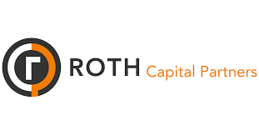

MAKE A DIFFERENCE!
BECOME A MEMBER OF NGO SUSTAINABILITY!
SEE CORPORATE SPONSORSHIP OPPORTUNITIES
unngosustainability.org

Aayat Irfan. "There Once Used To Be Green", 2021. https://www.voicesofyouth.org/blog/code-red-there-once-used-be-green

